**Documentation for the project1:Dr Snow’s Cholera Map 1854**

This project is the replication of the Dr John Snow Map of 1854 Cholera Epidemic of London.

The rough sketch of the visualization is shown below:

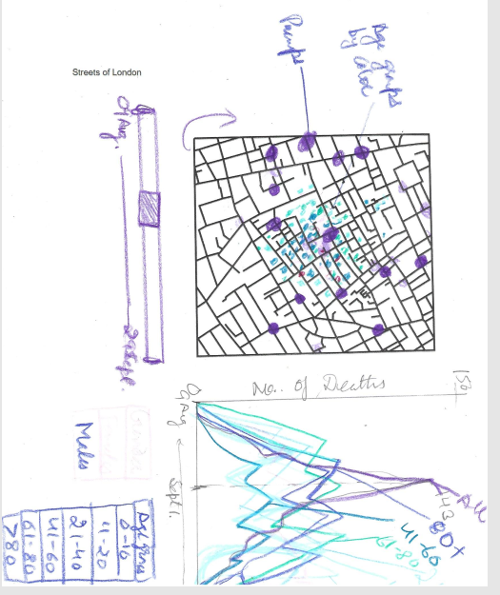

The visualization has two parts:

* Map and
* charts

**Map-**The map is plotted by coordinates data. On the map the deaths by sex are shown by shapes-Females by Circle and Males by Rectangle 

Different Age groups shown by different color codes:

0-10 Yellow,11-20 Red,21-40green,41-60-pink,61-80 , above 80 blue

The water pumps are shown as big circles in deepblue color.

**Charts: T**here is a chart of total number of deaths on a day between 19August to 29 September 1854. Another chart showing deaths by sex-male and females and the third chart to show the deaths by different age groups. The plan was to make the tree charts overlapping and filter by sex and different age groups.

**Analysis:** The Visualization clearly shows that number of deaths are more in some areas near the water pumps. The deaths are more in the age groups of 0-10 and above 80 years. There was no big difference in the number of deaths by sex. The maximum deaths were on sept 1,1854. Total number was 143.